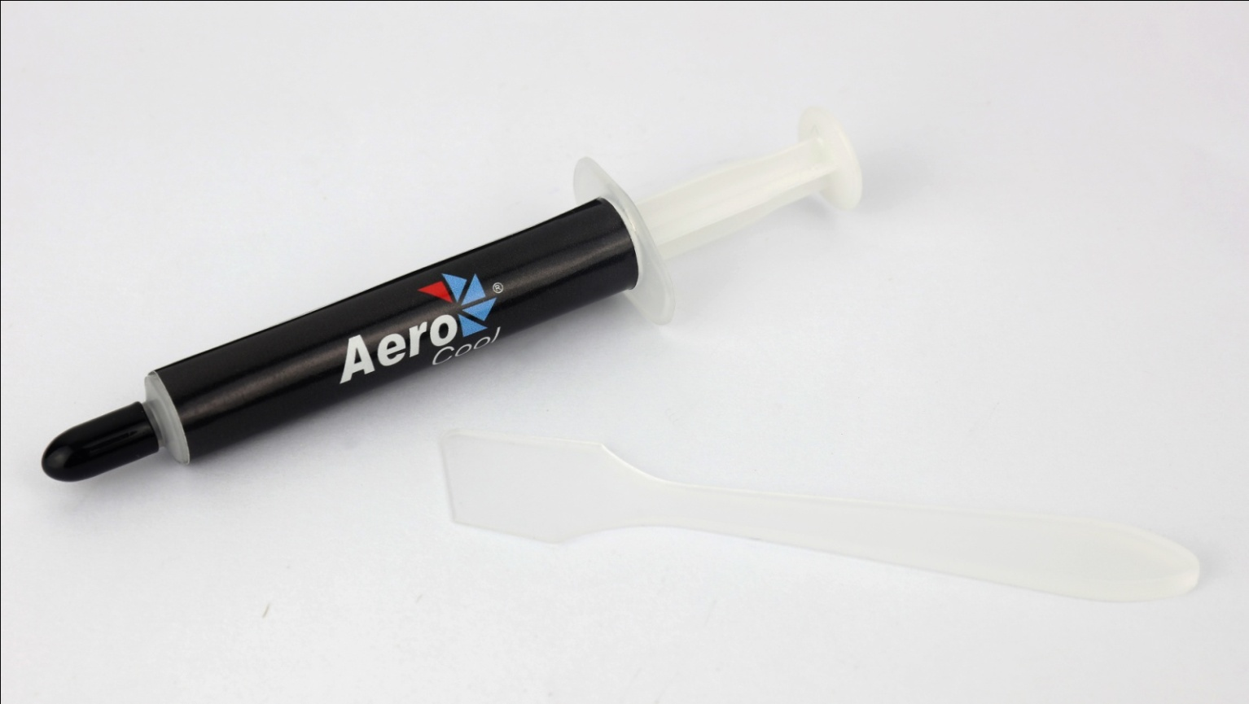

Product Overview:
Baraf-S 2g is a high performance thermal paste that enhances the efficiency of heat conduction. Easy to apply and perfectly fills between your cooler and CPU. Comes with spreader.
Specifications

Model | Baraf-S 2g
Thermal Conductivity | >5.15 W/m-K
Thermal Impedance | <0.004 ℃-in2/W
Specific Gravity | >3.25
Viscosity | 12500
Moment Beared Temperature | -50~340℃
Operation Temperature | -30~280℃
Ingredients
Silicone Compounds | 10%
Carbon Compounds | 45%
Metal Oxide Compounds | 45%
Weight
Net Weight | 2g

Warranty

1 year

Features

- High performance thermal grease.
- Includes Spreader.

Package Information

Product Name | Product Number | EAN CODE | UPC CODE
Baraf-S 2g | ACTG-NA22210.01 | 4710700950838
Carton Size ( L x W x H ) | 558 x 470 x 320 mm | Carton Weight | N.W 4.5 kg / G.W 5 kg
Retail Box Size ( L x W x H ) |  | Retail Box Weight
Carton Qty | 1000 pcs | Pallet Qty | 24000(GP) / 28000(HQ)
FTP for pictures download:

